**Figure 1**. Distribution of *Quercus pyrenaica* forests in Iberian Peninsula (a) and in Sierra Nevada mountain (b). Different colours indicate oak population cluster’s identified in Sierra Nevada (Pérez-Luque et al. 2015). For each population, a grid with the MODIS pixels is shown (see material and methods). Detailed location of the dendroecological sampling sites: northern (San Juan, SJ) (c), and southern ones (Cáñar: CA-Low and CA-High) (d). Colour orthophotography of 2009 from Regional Ministry of the Environment, Regional Government of Andalusia.

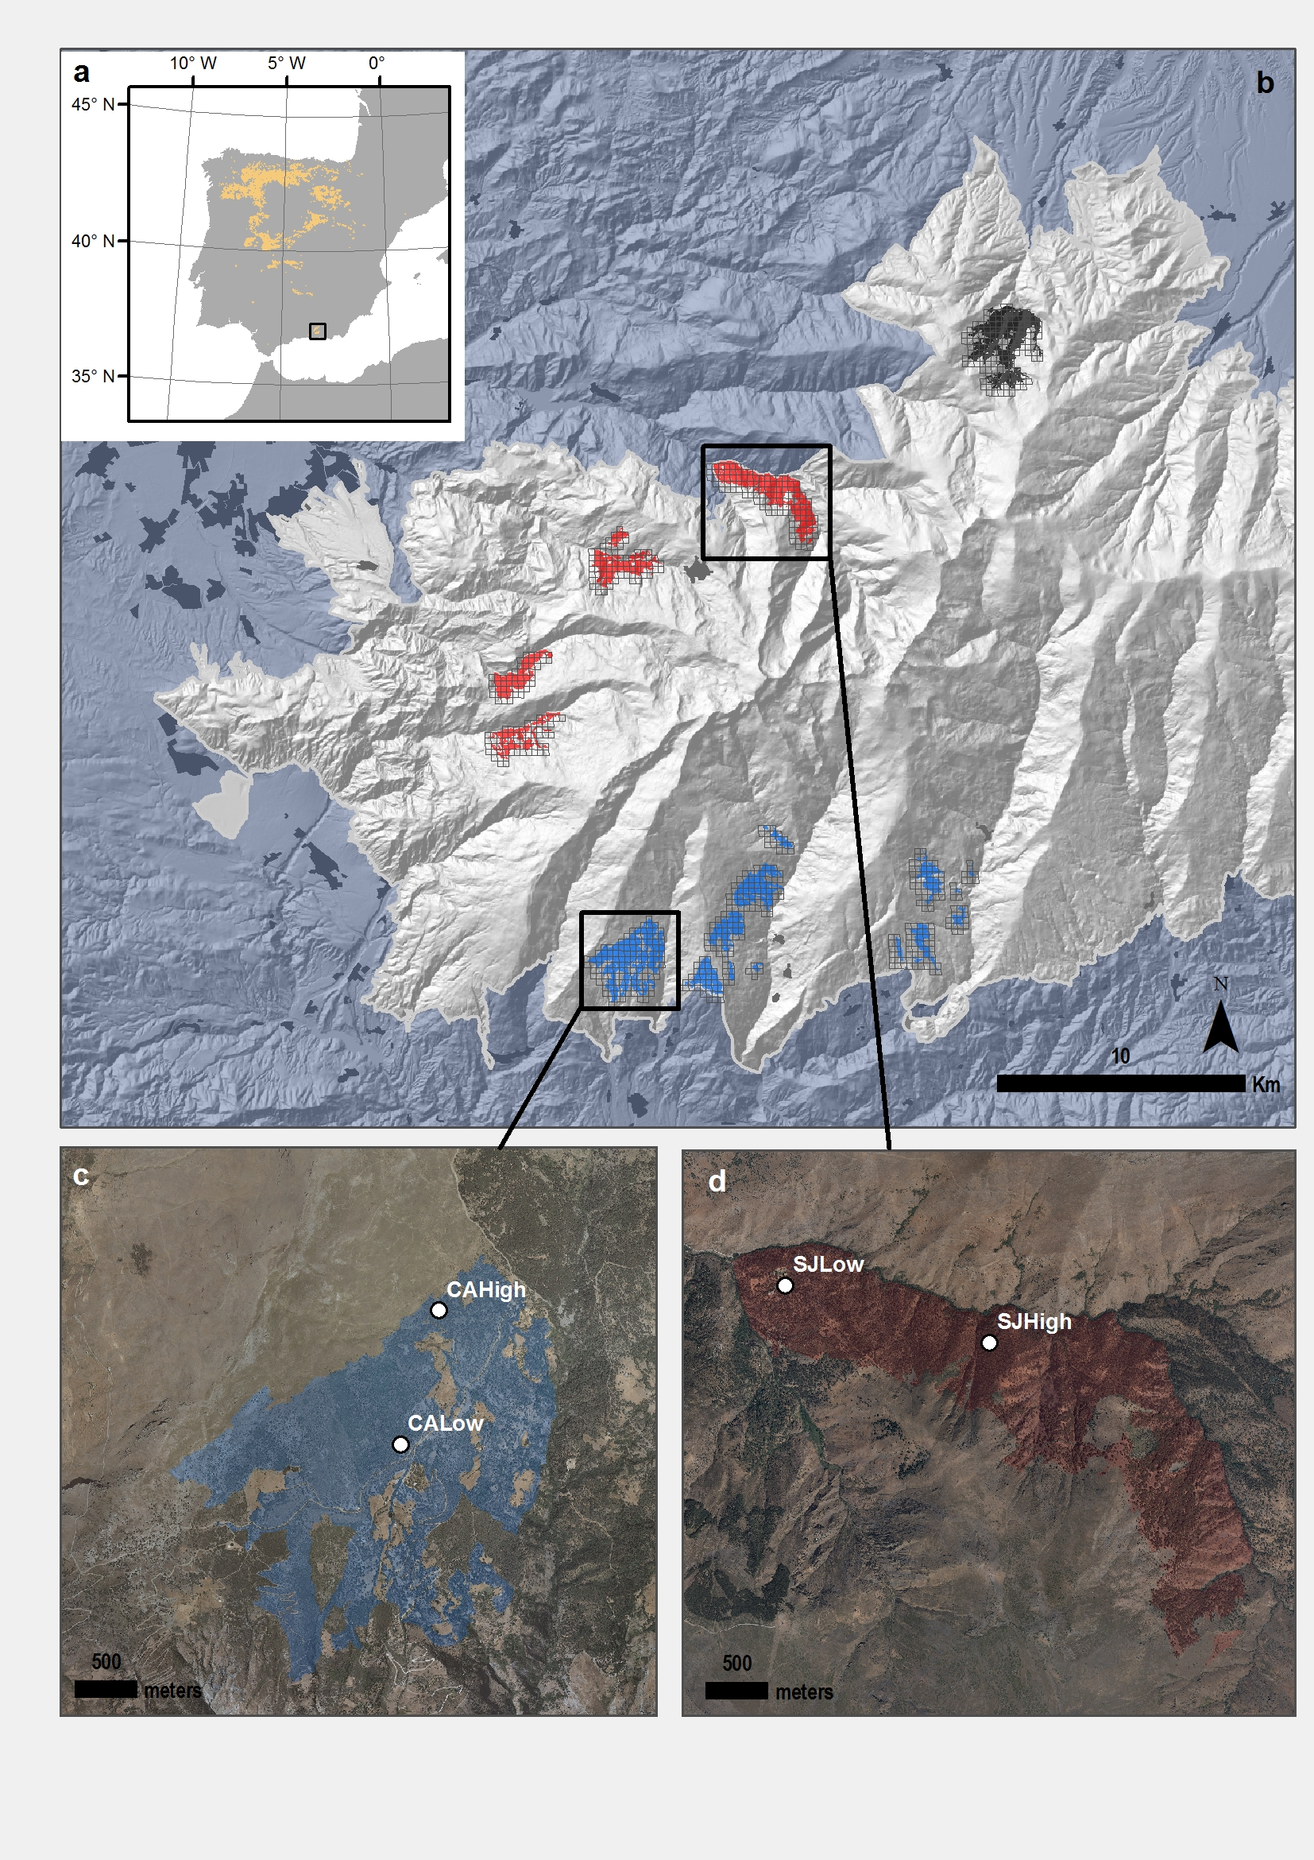

**Figure 2.** EVI standardized anomaly during the period 2000-2016 for northern and southern populations. Error bars show standard error.

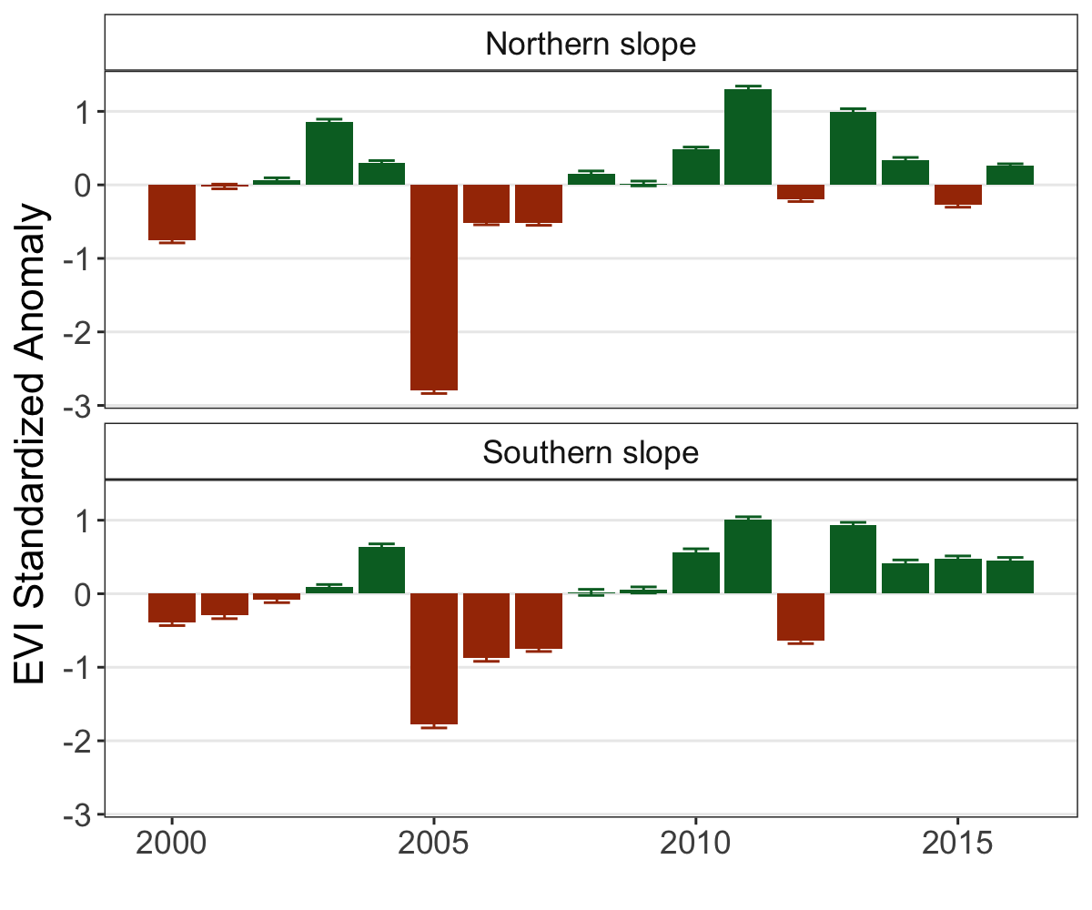

**Figure 3.** Response *Q. pyrenaica* forests to drought in terms of resistance, recovery and resilience of greenness (EVI; left-plots) and tree radial growth (BAI; right-plots) for the years 2005 and 2012. For EVI we compared northern populations (*black fill circle*) with southern ones (*blue empty circle*). For BAI we compared northern population (San Juan, SJ; *black triangle*) with southerns populations: Cáñar-High (CA-High; *blue empty squares*) and Cáñar-Low (CA-Low; *blue fill squares*). Different letters above error bars indicate significant *post hoc* differences between groups (see material and methods).

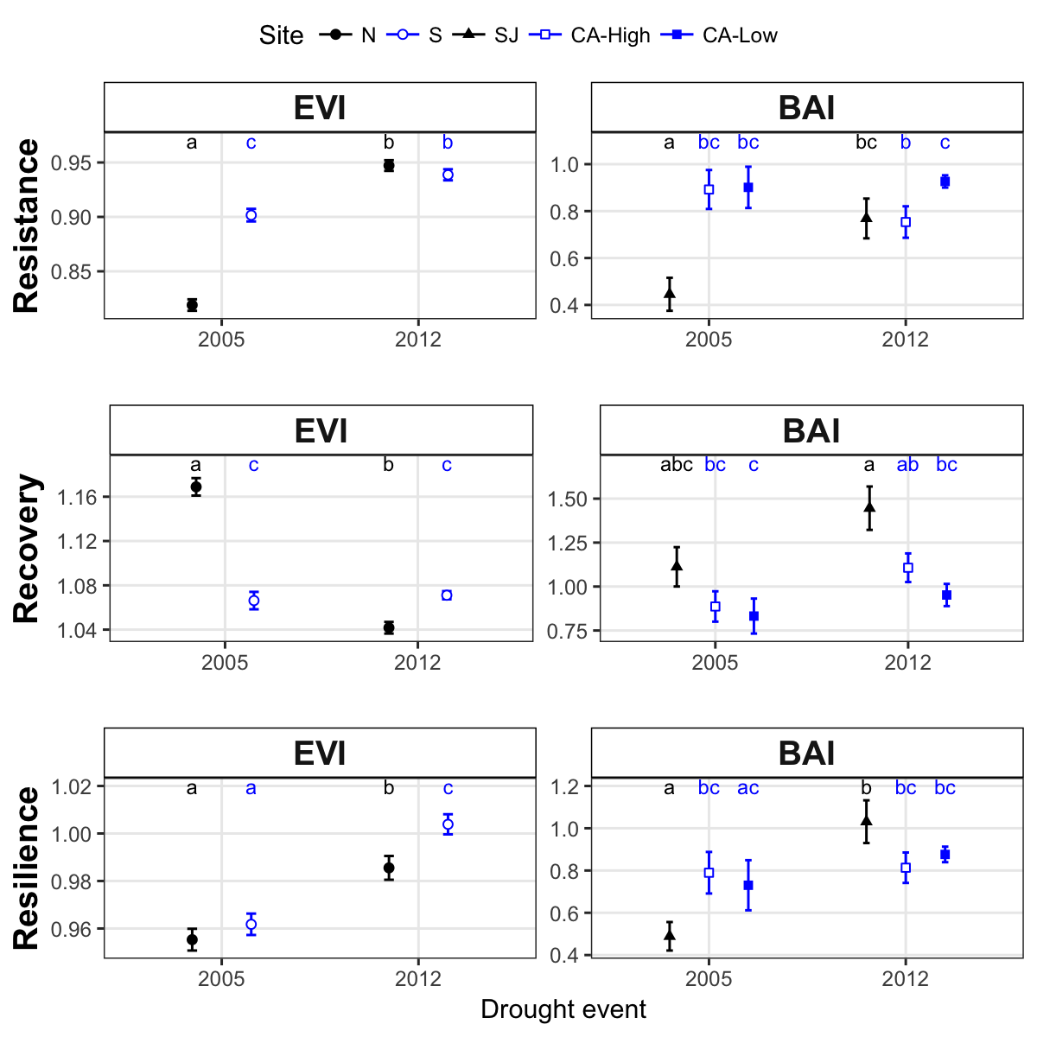

**Figure 4.** Basal Area Increment (BAI) chronologies of *Q. pyrenaica* for northern population (SJ; *green*) and southern ones: low-elevation (CA-Low; *pink*) and high-elevation (CA-High, *purple*) sites. Shading areas coorespond to standard error of the mean. Number of series are displayed in the upper plot. We only show chronologies with # trees > 5. Linear trend since 1975 is shown for southern high-elevation site (CA-High) ( $r_{2}$ = 0.303).

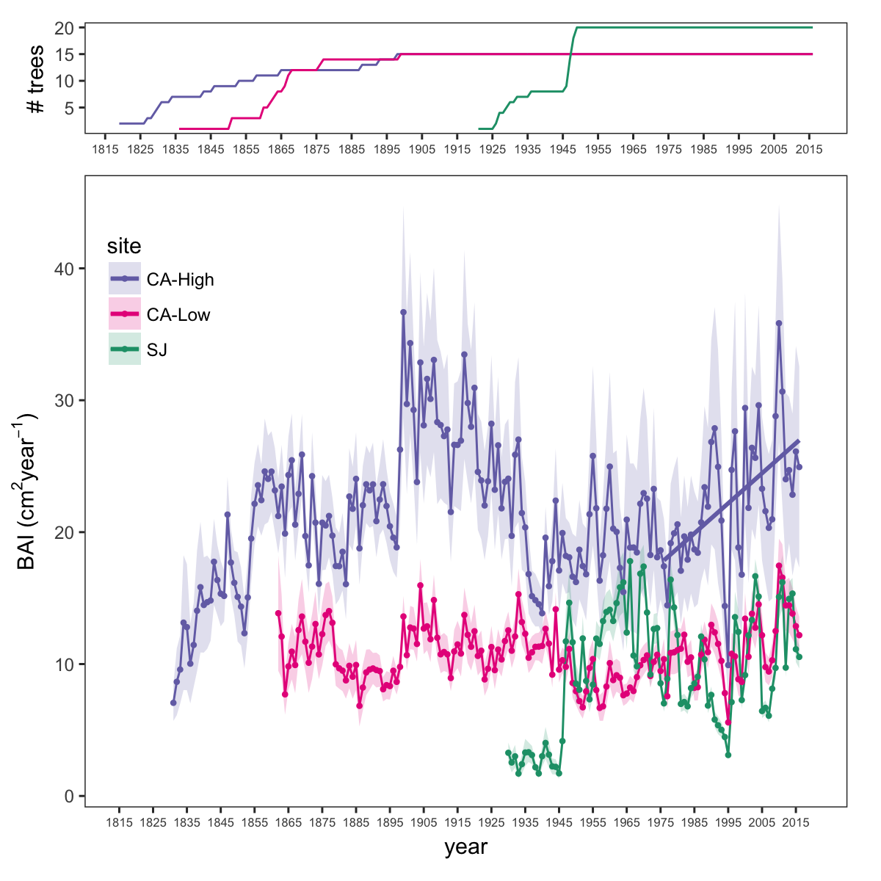

**Figure 5.** Residual tree-ring chronologies obtained for the *Q. pyrenaica* sites. Dashed red lines indicate the start of the reliable period (EPS > 0.85). Dotted black lines showing the three of most recent severe drought years (1995, 2005 and 2012).

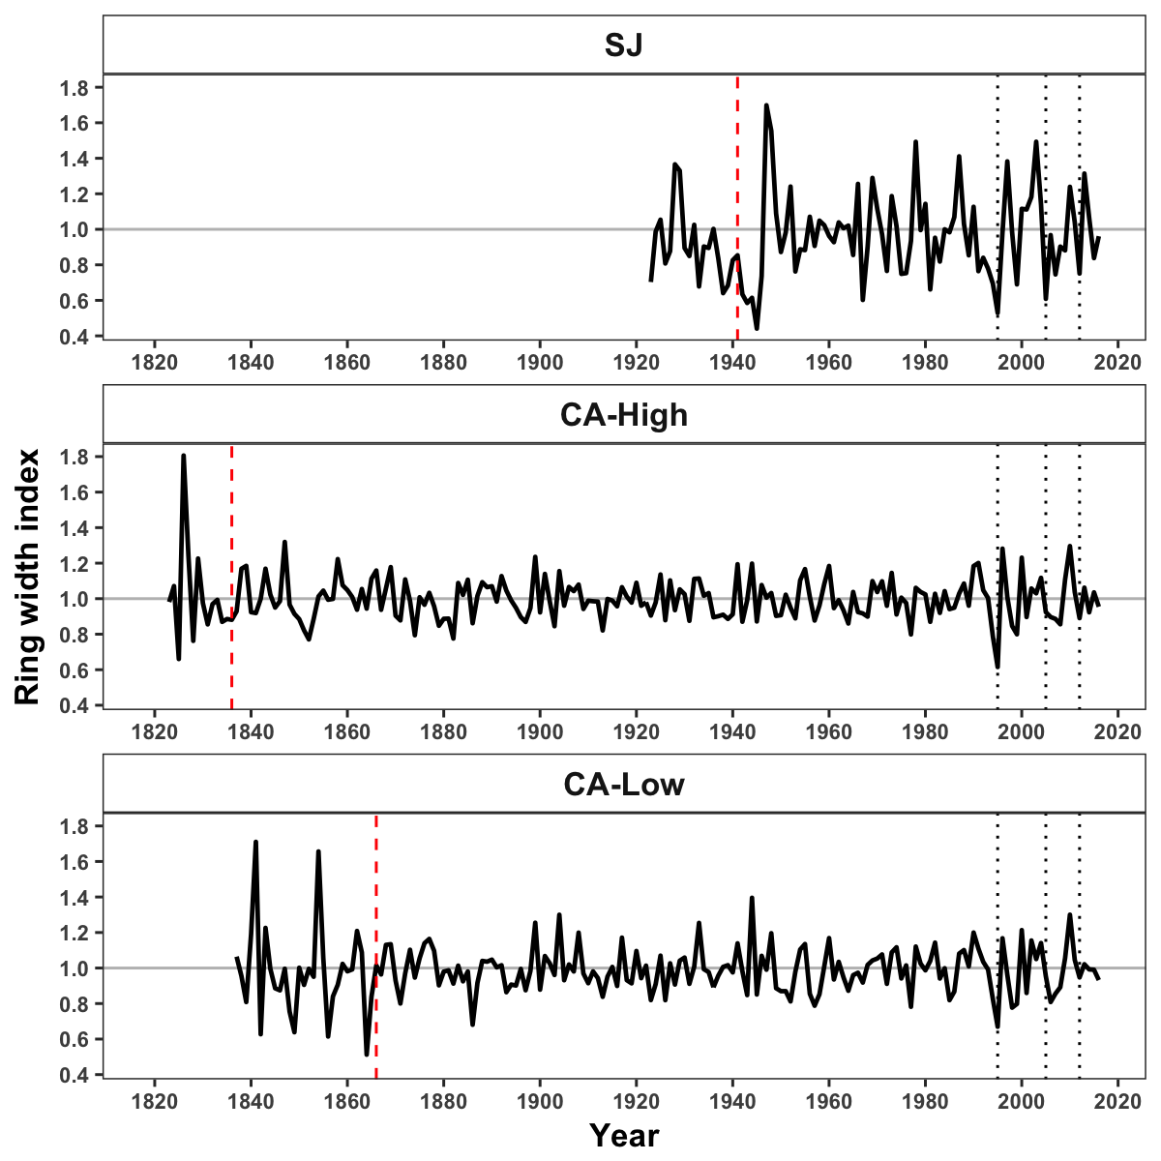

**Figure 6.** Correlation coefficients obtained by relating tree-ring residual chronologies (RWI) of *Q. pyrenaica* and monthly climatic data: precipitation (a), SPEI (b), maximun (c) and minimun (d) temperatures. *green* bars: northern site (SJ); *light blue* bars: low-elevation southern site (CA-Low); and *dark blue* bars: high-elevation shouthern site (CA-High). Asteriks indicate significant ($P<0.05$) correlation coefficients.

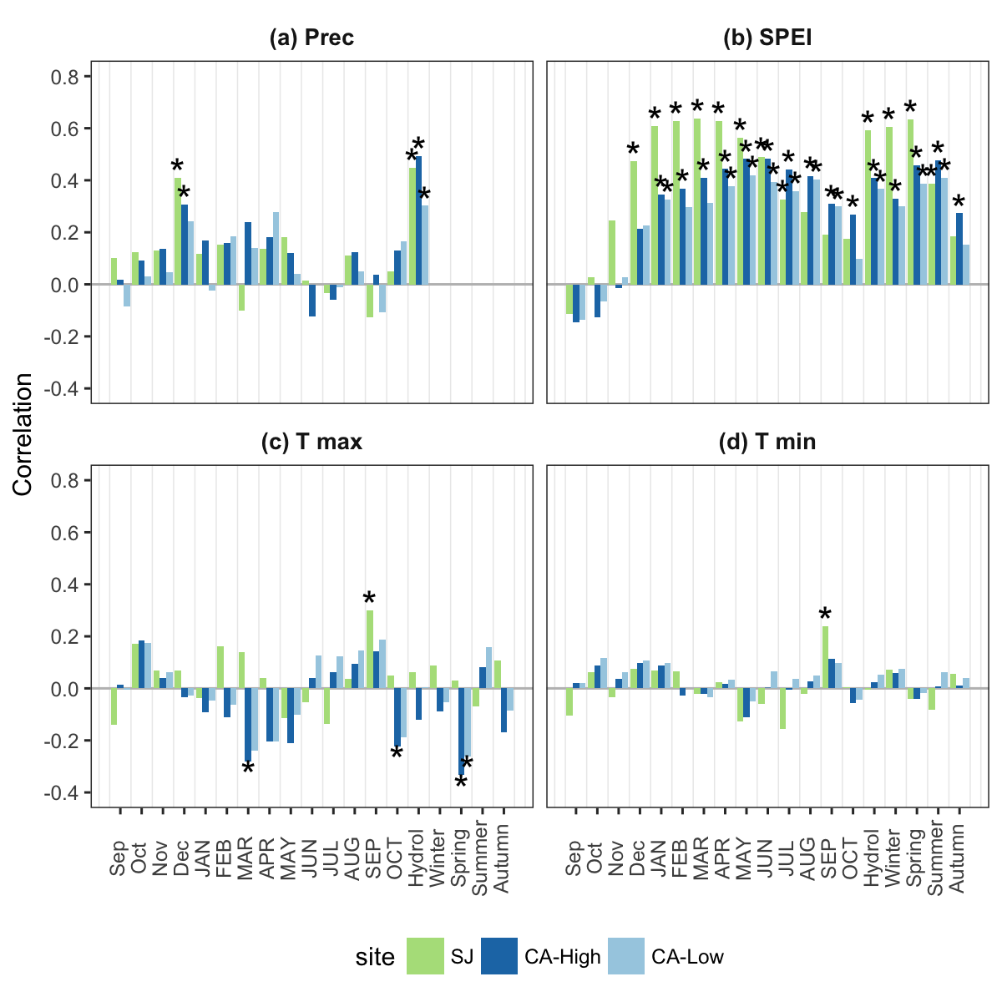

**Figure 7.** Comparison of median growth change ($GC$) following Nowacki and Abrams (1997) for *Q. pyrenaica* sites. Dashed black lines indicate a threshold of 50 % of GC (see material and methods).

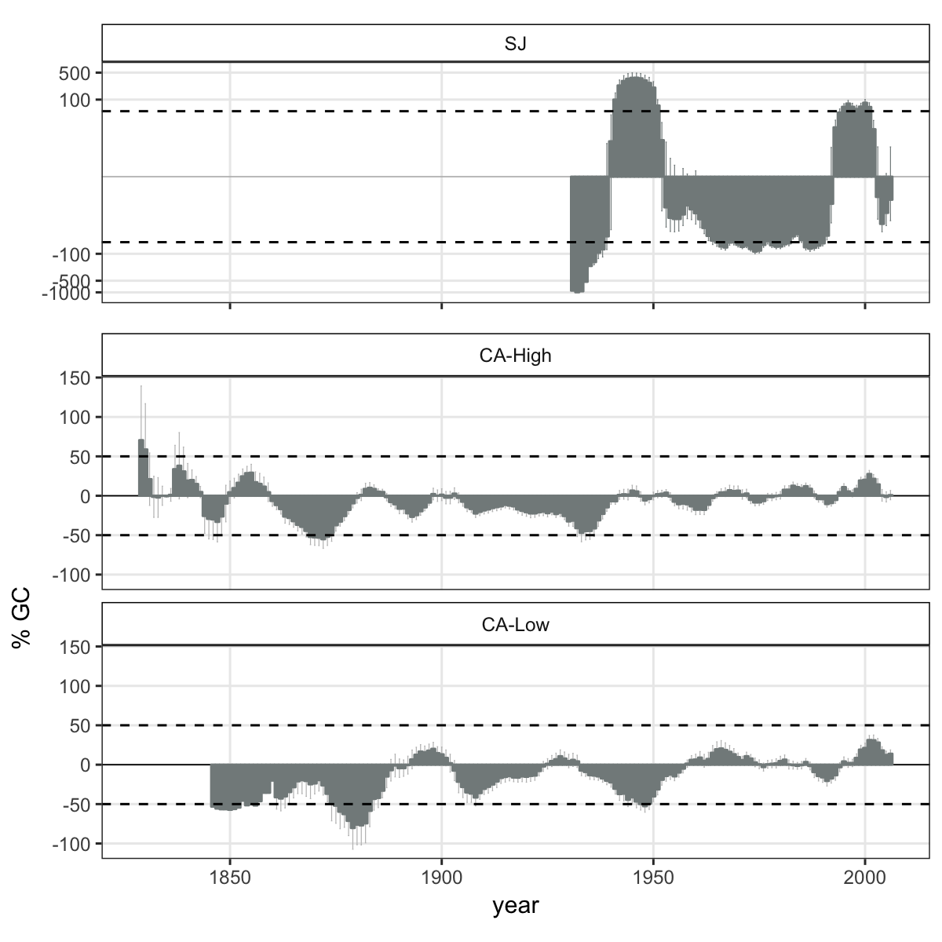

**Figure 8**. Percentage of *Q. pyrenaica* trees affected by GC > 50 % by site. *Black* line shows number of trees (rigth-axis).

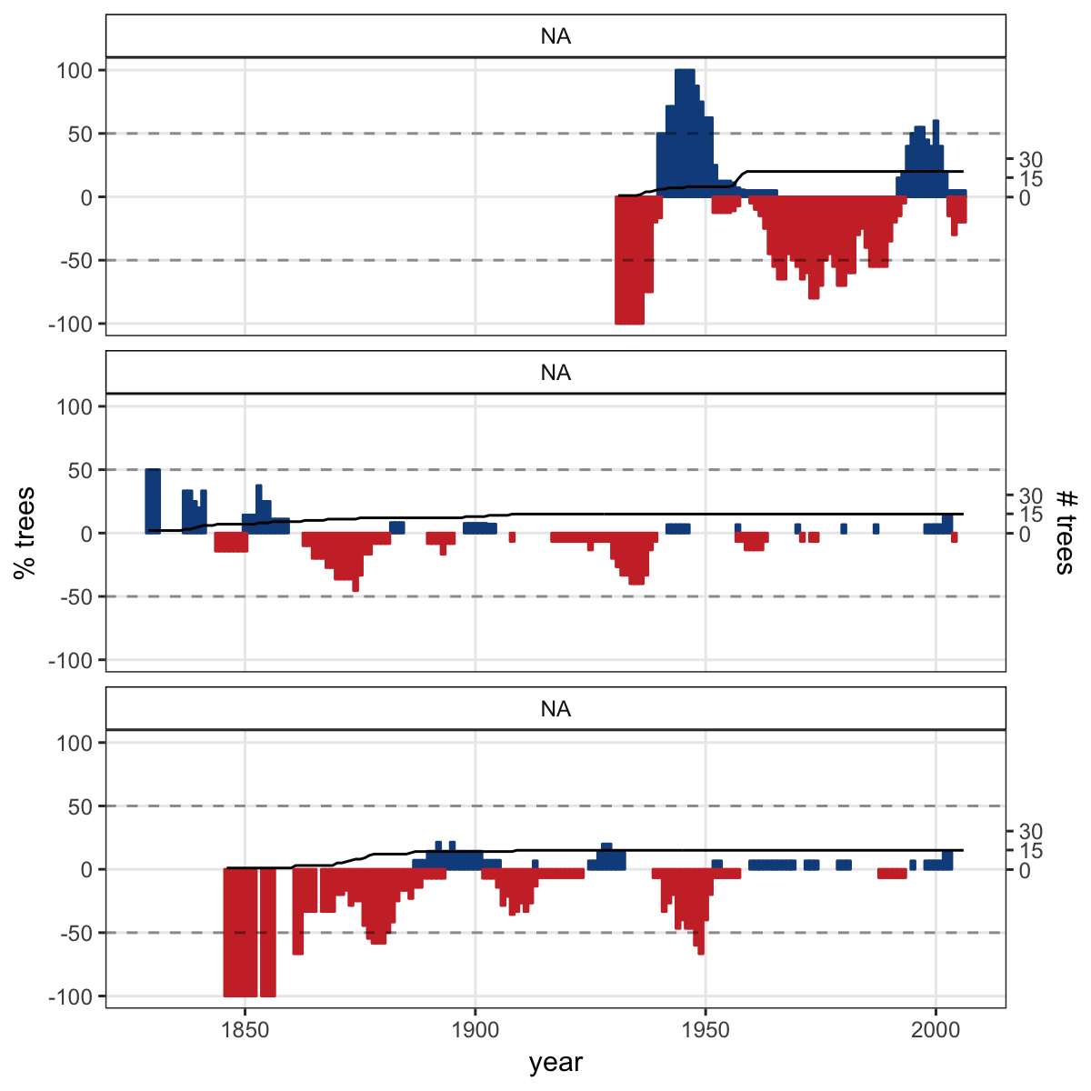

##### **Appendix S1.** Temporal evolution of cumulative precipitation (hydrological year) during the period 1950-2017. Points represent mean and errorbars standard error. *Black* line indicates mean for all period. *Red* lines represent -1 and -2 standard deviation (*dotted* and *dashed* lines respectively). *Blue* lines represent +1 and +2 standard deviation (*dotted* and *dashed* lines respectively). Years with average values below -1SD are labelled. Data from 28 meteorological stations distributed around Sierra Nevada area (from National Spanish Meteorological Services, AEMET). ***Inset plot***: cumulative precipitation during the hydrological years 2004-2005 (*blue line*) and 2011-2012 (*red line*). The boxplot representing the average from 1950-2015 period. Data from meteorological station Granada, Base Aérea.

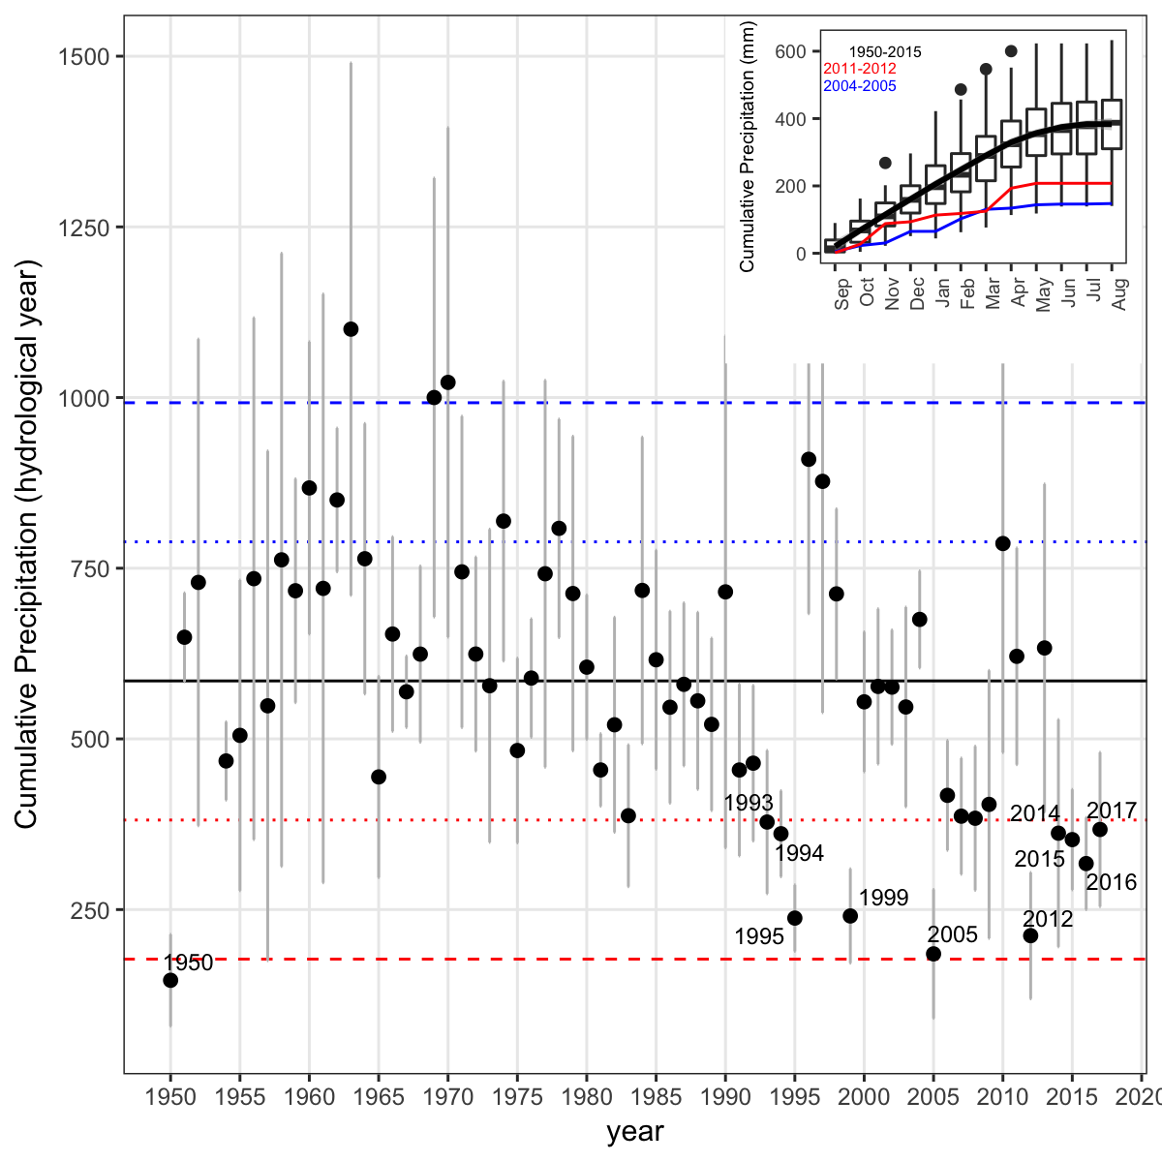

**Appendix S2**. Drought severity in the Sierra Nevada for the 1950-2016 period based on the Standardised Precipitation-Evapotranspiration Index (SPEI). Data from Global SPEI database (<http://spei.csic.es/database.html>). We obtanied the SPEI data for a 12 month scale and for all 0.5º grid cells covering Sierra Nevada.

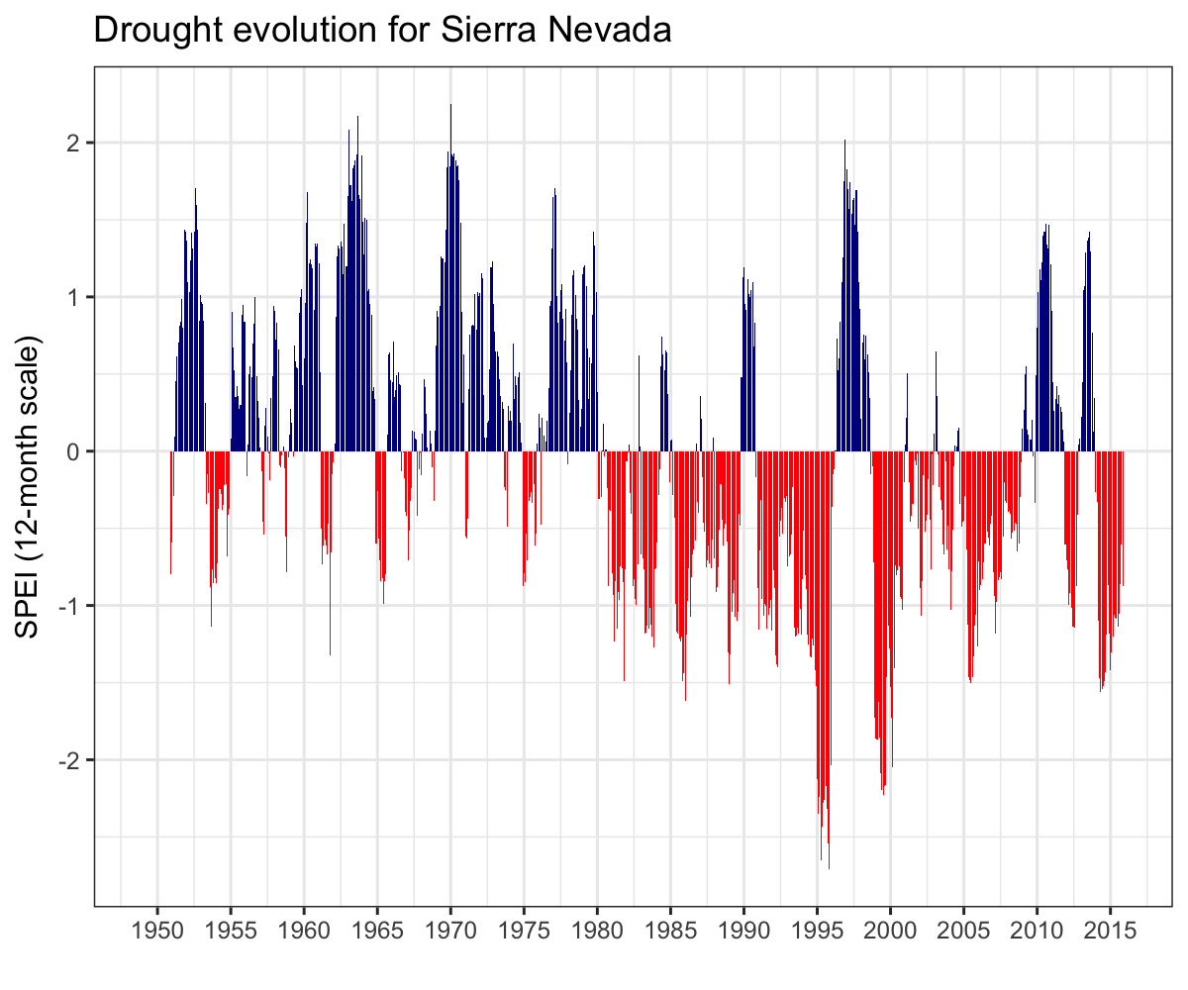

**Appendix S3.** Drought events for Sierra Nevada based on SPEI index. A drought event starts in the month when SPEI falls below the threshold of -1.28 (Páscoa et al. 2017). A drought event is considered only when SPEI value are below threshold for at least two consecutive months (*e.g.* Spinoni et al. 2015, 2017, Páscoa et al. 2017). The ***duration*** of a drought event is the number of consecutive months with the SPEI lower than a certain threshold. ***Severity*** of a drought event is the sum of the SPEI values (absolute values) during the duration of the drought event. ***Intensity*** and ***Lowest SPEI*** refer to the mean and lowest value of SPEI respectively during the drought event duration.

|  |  |  |  |  |
| --- | --- | --- | --- | --- |
| Duration (months) | Intensity | Severity | Lowest SPEI | Year |
| 11 | -1.581 | 17.39 | -2.024 | 1913-1914 |
| 11 | -1.957 | 21.52 | -2.585 | 1995 |
| 9 | -1.823 | 16.41 | -2.427 | 1945-1946 |
| 9 | -1.764 | 15.88 | -2.056 | 1998-1999 |
| 8 | -1.482 | 11.86 | -1.654 | 1983 |
| 6 | -1.728 | 10.37 | -1.906 | 2012 |
| 5 | -1.905 | 9.527 | -2.3 | 1925 |
| 5 | -1.493 | 7.463 | -1.537 | 1985 |
| 5 | -1.385 | 6.926 | -1.444 | 1991 |
| 5 | -1.522 | 7.611 | -1.571 | 2005 |
| 4 | -1.363 | 5.453 | -1.441 | 1927 |
| 4 | -1.714 | 6.855 | -1.833 | 1931 |

**Appendix S4.** Percentage of pixels showing browning, greenning or no-changes during the 2005 and 2012 droguht events according to EVI standardized anomalies.

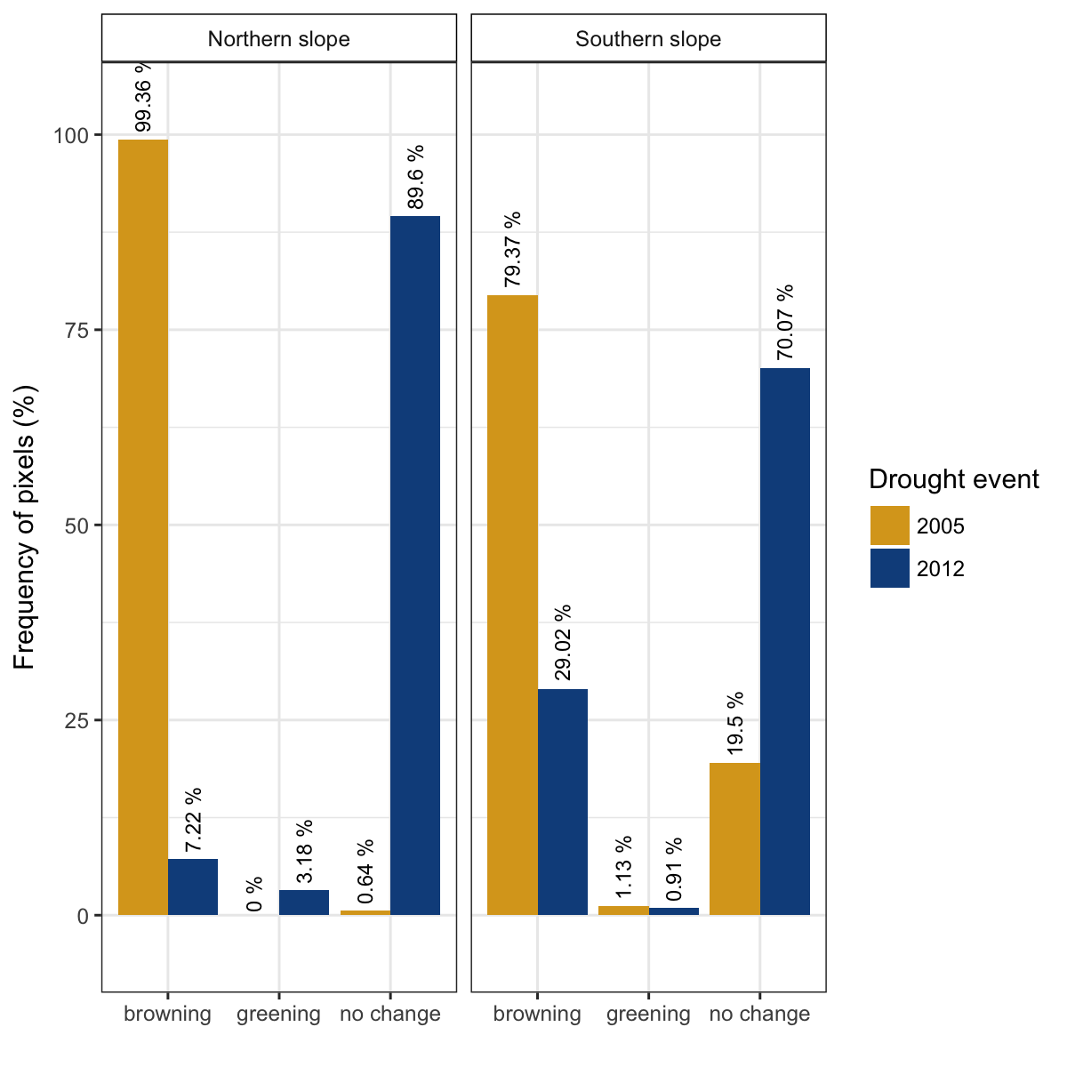

**Appendix S5.** Resilience metrics of the tree-growth for the most severe drought events. *Left*: Resistance (*Rt*); *Center*: Recovery (*Rc*); *Right* Resilience (*Rs*). Points indicate average of resilience metrics for all populations. Error bar corresponds standard error. Resilience metrics were computed for each population (sample depth > 10) and drought event.

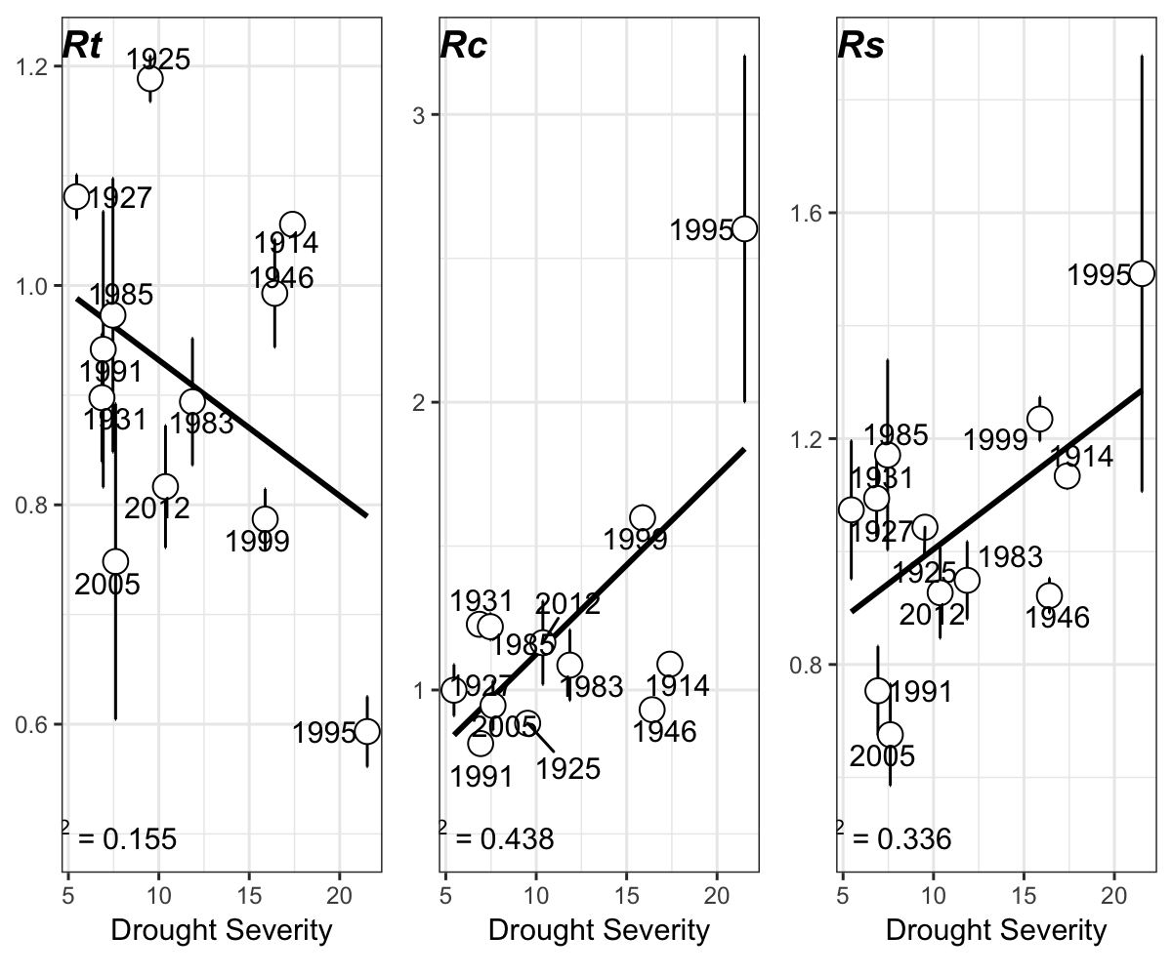

**Appendix S6.** Correlation between indices of resilience (*Rt*, resistance; *Rc*, recovery; *Rs*, Resilience) using periods of several lengths (2, 3 and 4 years after a drought). Top plots (a, b and c) showing the resilience indices of greenness (EVI) to drought; and bottom plots (d, e, f) the resilience indices of tree-growth (BAI) to drought.

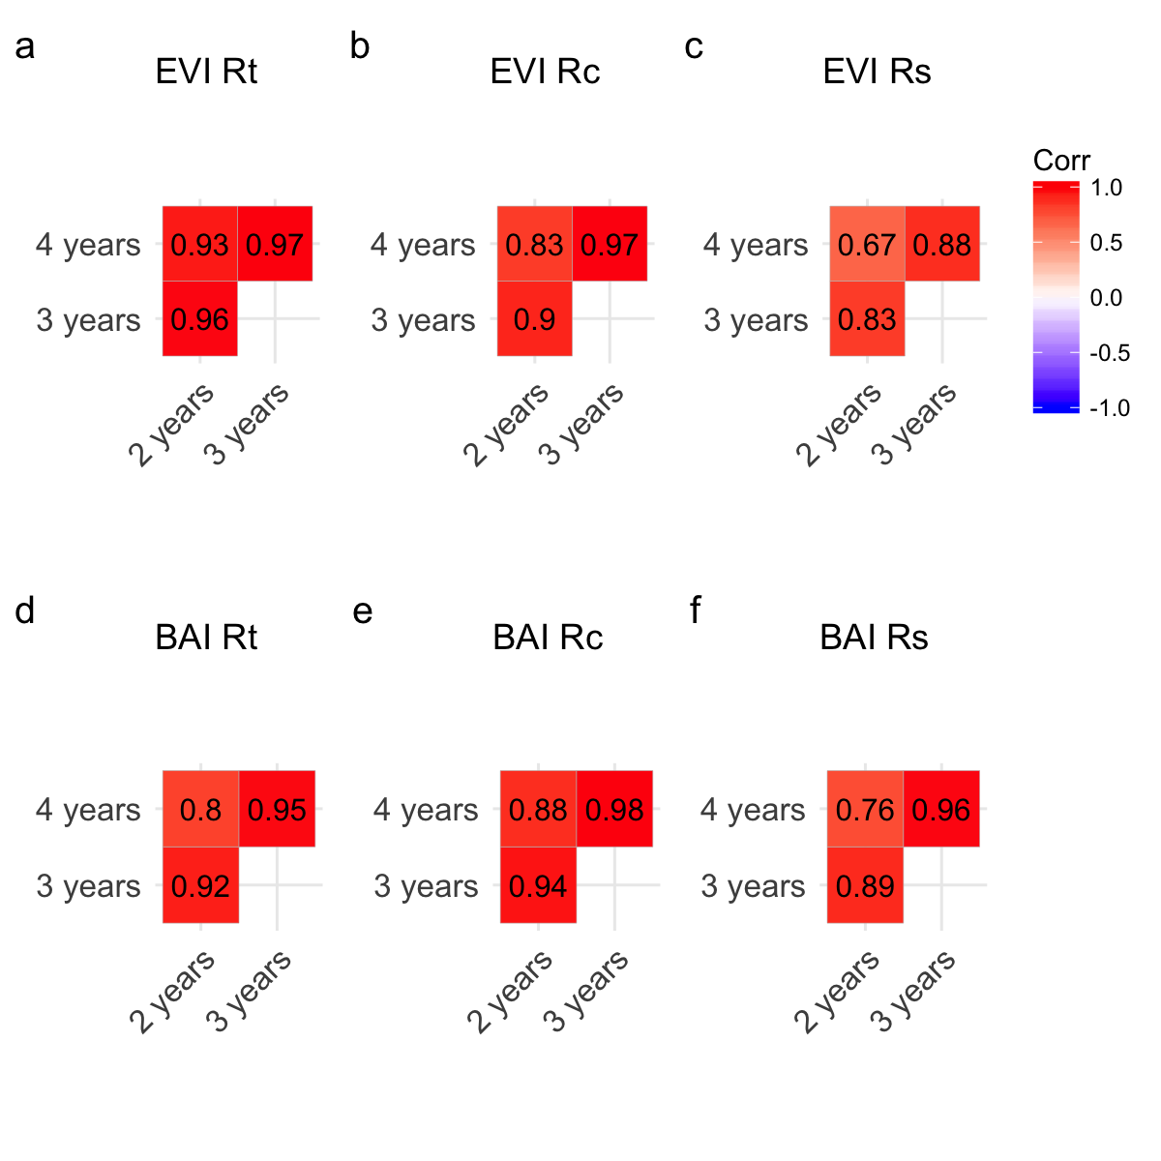

**Appendix S7.** Correlation among site chronologies (CA-High, CA-Low and SJ) in different time-domains after pre-filtering the time-series with increasing size of the moving-average window (1 to 40 years). Each site chronology was smoothed using centred moving averages with different window sizes (1 to 40 years), and then Pearson’s correlation coefficient between the each pair chronologies were calculated. Significance was tested using 1000 boostrap replicates and with 95 % confidence intervals built using the R packgae boot (Canty and Ripley 2016).

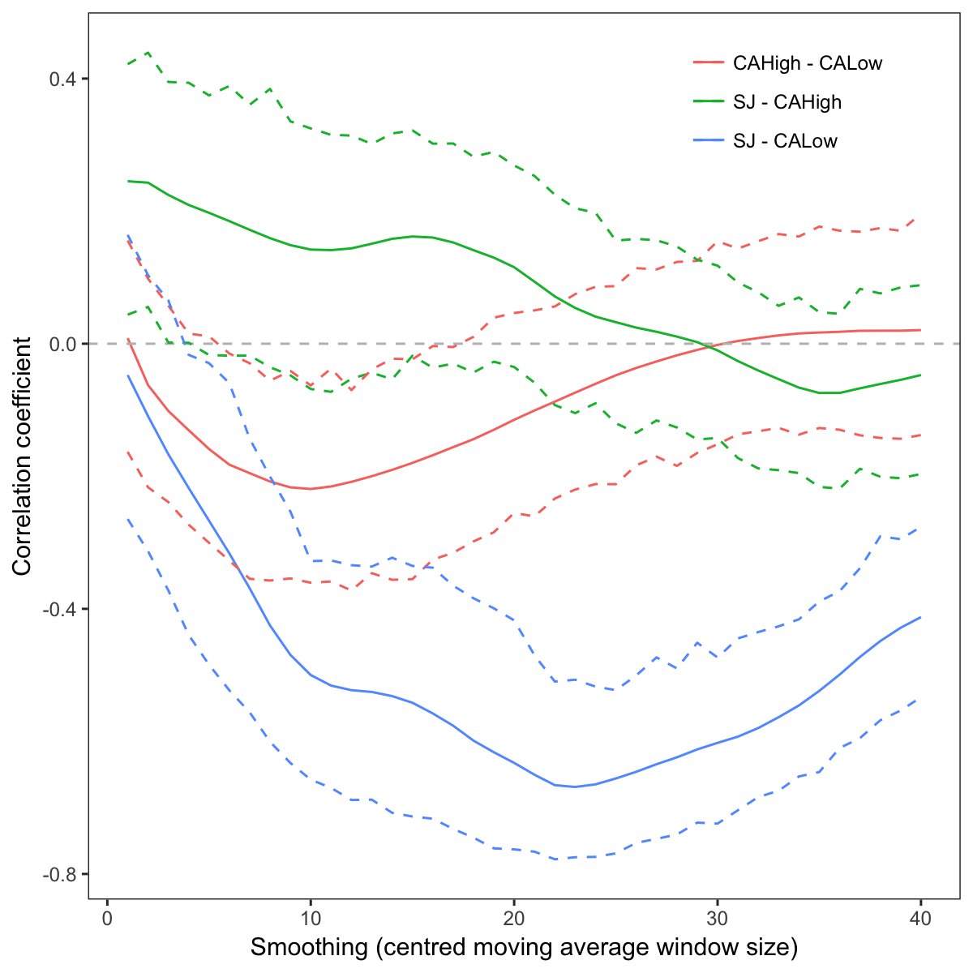

**Appendix S8.** Tabla S1

##### 

**Appendix S9.** Tabla S2